
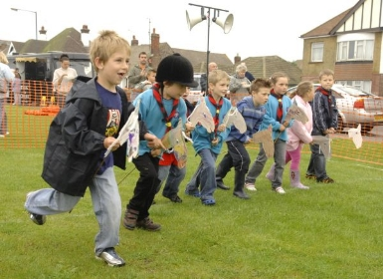

BUCK CANCER DAY
AT SCHOOL NAME
WHEN: DAY, DATE
WHAT: Bring a Buck ($1 or more, no coins please) to donate.
WEAR: Cowboy/cowgirl clothes to school
BRING: hobby horse or toy horse.
JOIN: The (school name) Stampede Against Cancer at (time) at (location) lead by (Principal and/or teachers names).

WHY: We are saddling up to help the Leukemia & Lymphoma Society fight cancer. Bring in a Buck to donate to the cause of finding cures and saving lives. Donations will be collected before the start of the stampede!



